Eukaryotic Organelles
Student’s Name
Institutional Affiliation
Date of Submission

Eukaryotic Organelles
The differences between the two organelles such as prokaryotes and eukaryotes are crucial when highlighting their differences among groups of organisms. Naturally, eukaryotic cells have membrane-bound organelles, like nucleus which lack among the prokaryotic cells. Also, the distinction between the two organelles in their cellular structure is the availability of mitochondria, chloroplasts and the cell wall.
Mainly eukaryotic cells include membrane-bound nuclei that comprise of endoplasmic reticulum, Golgi apparatus, chloroplasts and mitochondria and several rod-shaped chromosomes. Each organelle has specific cellular roles which help in easy functioning of the organelle with the area of the cell.
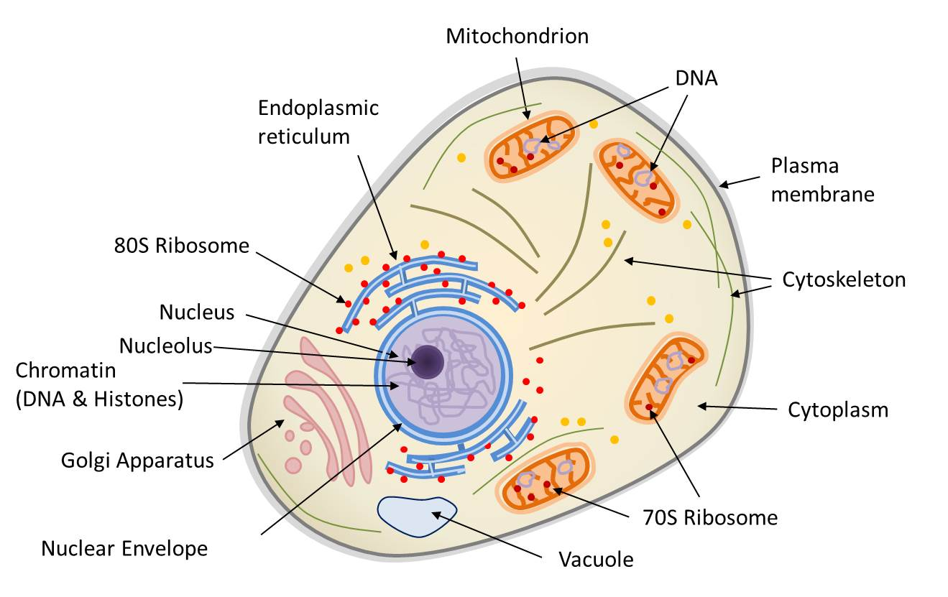Figure 1: Structure of eukaryotic cell
Structure and function of the eukaryotic organelles
Organelles are tiny structures within a cell that functions a specific role in a cell. Various types of organelles are found in eukaryotic cells that are mandated towards performing a specific role.
Nucleus
The nucleus is the small structure that is found in eukaryotic cells that are commonly known as true nucleus because of the membrane coverage. This is the same membrane that stores the DNA and transcribing the RNA. The nuclear envelope is a double-membrane structure that covers the outermost part of the nucleus. These two membranes are phosphatide in layers. Only the nuclear pores are responsible for transportation of the RNA and the protein out of the nucleus. Nucleoplasm is the semi-solid fluid in the nucleus that is responsible for the storage of chromatin and nucleolus.
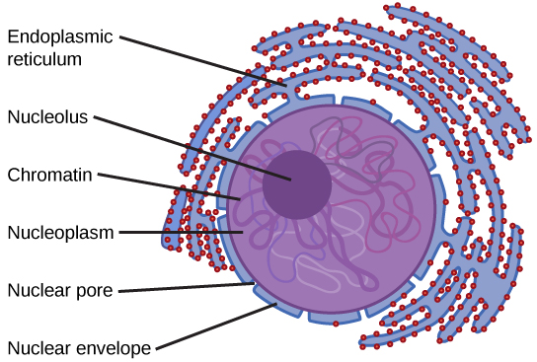
Figure 2: Structures of the Nucleus

Membrane-Bound and Non-Membranous Organelles
Ribosomes
Here is where protein synthesis and the RNA changed to protein. Naturally, they exist as they float freely in the cytoplasm, hence bounding to the endoplasmic reticulum. This bounding is called rough endoplasmic reticulum since the ribosomes seem to be black dots on the ER when viewed on an electronic microscope. They are quite small with no membrane that made up of 50 proteins and several RNAs bounded together.
Mitochondria
This is where the aerobic respiration takes place which is the key when it comes in the energy production with the eukaryotes organelle. It consists of the two membranes such as inner and an outer membrane. The presence of these two membranes has led biological studies on mitochondria by the biologists on its formation over the years ago but not being digested by the cell. Due to this study by the biologist led to the evolution of a certain theory called symbiosis that explains more details on the formation of the eukaryotic cells. Mitochondria have always acted independently by having its DNA and ribosomes (Alberts, 2002).
Endoplasmic Reticulum
The endoplasmic reticulum is responsible for the transportation of the molecules purposely for the modifications. The endoplasmic reticulum is grouped into two such as rough and smooth endoplasmic reticulum (Alberts, 2002). To differentiate the two, rough endoplasmic reticulum has ribosomes that are attached to it while smooth endoplasmic reticulum does not have ribosomes attached to it.
Golgi apparatus
Golgi apparatus is the organelle which is mandated to rework molecules towards packaging them into tiny membrane-bound sacs known as vesicles. After the packaging, the sacs are used up in the cell.
Lysosome
The lysosome is organelle that is responsible for the digesting all waste materials and food. Also, is responsible for breaking down molecules into small particles for easy digestion by the enzyme.
Peroxisome
These are small-round organelles that are covered by one membrane that is responsible for the carrying out oxidation reactions which break down fatty acids and amino acids, at the same time removing harmful substances from entering the body.
Cytosol
Cytosols are the protein-rich portion that remains after the removal of organelles that contain soluble enzymes. There are three major types of protein filaments namely actin microfilaments, microtubules and intermediate. In animal cells, these help to give stability within the cells structure contribute to cell movement for the effective growth.
Proteasomes
These are non-membranous that are hollow; cylindrical that is made up of protein. Proteasomes are responsible for breaking down of proteins from the endoplasmic reticulum and destroying normal regulatory proteins in the cytoplasm that are useless.
Cilia and flagella
Cilia and flagella are hair-like the cell that is responsible to serve as moving substances over the surface of the cell, also propelling sperm cells.
Nucleolus
The nucleolus is one part of the nucleus that contains the RNA. It helps in the formation of ribosomes in the cell organelle. Therefore, the membranous cell organelles are surrounded by double or a unit membrane while non-membranous organelles are not surrounded by any of these two.
Membrane-Bound Organelles
The membrane-bound organelles which are found in eukaryotic cells are rough RER, smooth endoplasmic reticulum, lysosomes, Golgi apparatus, mitochondria and plastids.
Non-membrane Bound Organelles
Non-membrane bound organelles that have no or does not contain membranes are ribosomes, proteasomes, cytoskeletal, flagella, structures, centrioles, nucleolus and cilia.
Importance of membrane structure and function
In eukaryotic cells, the plasma membrane is the one that is responsible for the movement of materials in and out of the cell. The cell membrane has some proteins that help in the coordination between the cells and the environment. These proteins also function as sending and receiving chemical signals and interacting with the cells of prokaryotic organisms during the process of infection. In the other hand, cell membranes involved in many cellular processes like cell adhesion, ion conductivity and cell signaling (Lodish, 2000).
Structures
The plasma membrane has a large number of proteins that provide the high number of the structure of the cell membrane such as protein-protein complexes, pickets and fences. Therefore, lipid bilayers are formed by the process of the self-assembly. The layer of the cell membrane is thin that have both hydrophilic and hydrophobic properties that make it form a continuous, spherical lipid bilayer of the cell membrane.
The cell membrane can form various types of super membrane structures like postsynaptic density, focal adhesion and different types of cell junctions within the cell membrane. Mostly, this structure performs its function for the cell adhesion, communication, exocytosis and endocytosis that are composed of specific proteins like integrin and cadherin.
Function
It surrounds the cytoplasm that separates the intracellular parts from the extracellular environment. Also, it anchors the cytoskeleton which is responsible for providing the correct shape of the cell. Naturally, the cell membrane is permeable that can regulate substances to enter and exit that are necessary for the survival of the cell (Cooper, 2000). The cell membrane acts the roles of selective filtering that enable only the selective substances to go inside or to leave outside the cell, hence protecting the cell from any harmful substances. However, for the effective transportation of the substances, the cell uses the following mechanisms:
- Osmosis and diffusion; for example, both carbon dioxide and the oxygen can move across the cell or plasma membrane by either osmosis or diffusion.
- Transmembrane protein channels and transporters; for example, sugars or amino acids diffuse passively through protein channels across the cell membrane by transmembrane transporters.
- Endocytosis; this is the pathway for solid particles into small molecules, ion and macromolecules.
- Exocytosis; cell membrane is responsible for the removal of undigested substances that are brought in by endocytosis process.
References:
Alberts, B., Johnson, A., Lewis, J., Raff, M., Roberts, K., & Walter, P. (2002). Drosophila and the molecular genetics of pattern formation: Genesis of the body plan. In Molecular Biology of the Cell. 4th edition. Garland Science.
Cooper, G. M., Hausman, R. E., & Hausman, R. E. (2000). The cell: a molecular approach (Vol. 10). Washington, DC: ASM press.
Lodish, H., Berk, A., Zipursky, S. L., Matsudaira, P., Baltimore, D., & Darnell, J. (2000). Molecular cell biology 4th edition. National Center for Biotechnology Information, Bookshelf.

